

DOCUMENT NAME

**Version1.0**

**Quốc Nhân**

**04/11/2019**

**VERSION HISTORY**

|  |  |  |  |  |  |
| --- | --- | --- | --- | --- | --- |
| **Version #** | **Implemented**  **By** | **Revision**  **Date** | **Approved**  **By** | **Approval**  **Date** | **Reason** |
| 1.0 | Quốc Nhân | 04/11/2019 |  |  | Create Document SRS version 1.0 |
|  |  |  |  |  |  |
|  |  |  |  |  |  |
|  |  |  |  |  |  |

Table of Contents

1. Introduction 3

1.1 Purpose 3

1.2 Intended Audience and Reading Suggestions 3

1.3 References 3

2. Overall description 3

2.1 Product Perspective 3

2.2 Deliverable 3

2.3 Purpose and Scope 3

2.4 Deliverable 3

2.5 Purpose and Scope 3

3. External Interface Requirements 3

3.1 User Interfaces 3

3.2 Hardware Interfaces 3

3.3 Software Interfaces 3

3.4 Communications Interfaces 3

4. USE CASES 3

5. SYSTEM FEATURES 3

6. data requirements 3

1.1 Data Logical Model 3

1.2 Data Dictionary 3

7. Quality attributes 3

# 

# Introduction

## Purpose

The real estate application is created by the 'Hello World' group and the file is created to determine the role, flow of user, quality attributes, functions, and data dictionary.

## **Intended Audience and Reading Suggestions**

* Leader
* Department head
* Employees

## References

File: (ConOps.doc)

# Introduction

## Product Perspective

Build a ‘real estate ' app so internal staff can interact such as:

* Account management
* Project management
* Statistical management, reporting
* Business trip manager
* Management quit
* Other functions

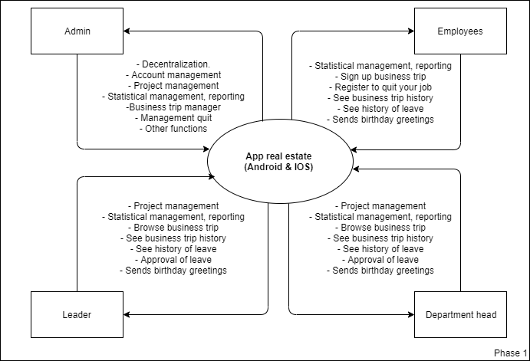

## **User Groups and Characteristics**

|  |  |  |
| --- | --- | --- |
| **#** | **User Groups** | **Descriptions** |
| 1 | Leader | - Project management  - Statistical management, reporting  - Browse business trip  - See business trip history  - See history of leave  - Approval of leave  - Sends birthday greetings |
| 2 | Department head | - Project management  - Statistical management, reporting  - Browse business trip  - See business trip history  - See history of leave  - Approval of leave  - Sends birthday greetings |
| 3 | Administrator | - Decentralization.  - Account management  - Project management  - Statistical management, reporting  -Business trip manager  - Management quit  - Other functions |
| 4 | Employees | - Statistical management, reporting  - Sign up business trip  - Register to quit your job  - See business trip history  - See history of leave  - Sends birthday greetings |

## Operating Environment

* Internet request system.
* Mobile app only supported on Android and IOS operating systems
* All data saved at real estate company

## **Design and Implementation Constraints**

Customer:

* Easy to interact
* Optional color
* Implementation on the App Android & IOS

## Assumptions and Dependencies

* Customers provide ANDROID and IOS accounts

# Introduction

## Purpose and Scope

## **Deliverable**

## Purpose and Scope

## **Deliverable**

## Purpose and Scope

# Introduction

## Purpose and Scope

## **Deliverable**

## Purpose and Scope

## **Deliverable**

## Purpose and Scope

# Introduction

## Purpose and Scope

## **Deliverable**

## Purpose and Scope

## **Deliverable**

## Purpose and Scope

# Introduction

## Purpose and Scope

## **Deliverable**

## Purpose and Scope

## **Deliverable**

## Purpose and Scope

# Introduction

## Purpose and Scope

## **Deliverable**

## Purpose and Scope

## **Deliverable**

## Purpose and Scope